Filed by Galera Therapeutics, Inc.

pursuant to Rule 425 under the Securities Act of 1933

and deemed filed pursuant to Rule 14a-12

under the Securities Exchange Act of 1934

Subject Company: Galera Therapeutics, Inc.

Filer’s SEC File No.: 001-39114

Date: June 2, 2026

This filing relates to the proposed transaction pursuant to the terms of that certain Agreement and Plan of Merger, dated as of April 14, 2026, by and among Galera Therapeutics, Inc., a Delaware corporation (“Galera”), Obsidian Therapeutics, Inc., a Delaware corporation (“Obsidian”), Gazelle Parent, Inc., a Delaware corporation (“Parent”), Onyx MergerSub, Inc., a Delaware corporation and a direct, wholly owned subsidiary of Parent (“Obsidian Merger Sub”), and Gazelle Merger Subsidiary, Inc., a Delaware corporation and a direct, wholly owned subsidiary of Parent (“Galera Merger Sub”), pursuant to which, and subject to the satisfaction or waiver of the conditions set forth in the Merger Agreement, Galera will be merged with and into Galera Merger Sub, with Galera surviving as a wholly owned subsidiary of Parent (the “Galera Merger”), and Obsidian will be merged with and into Obsidian Merger Sub, with Obsidian surviving as a wholly owned subsidiary of Parent.

On June 2, 2026, Obsidian published the following communication:

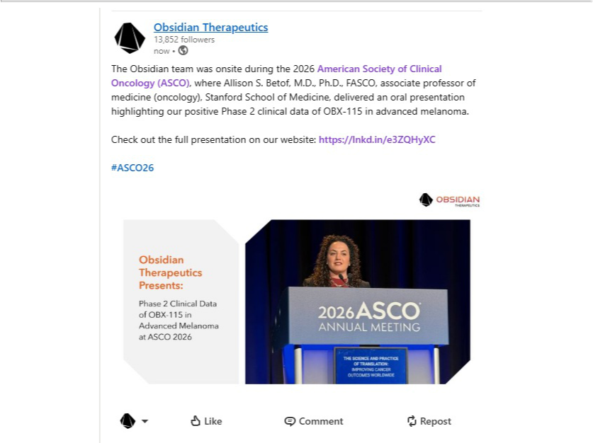

Additional Information and Where to Find It

In connection with the proposed transactions between Obsidian and Galera, Galera and the newly formed company formed in connection therewith will file relevant materials with the SEC. The newly formed company has filed a registration statement on Form S-4 that includes information statement and prospectus relating to the proposed transaction, which constitutes an information statement of Galera and a prospectus of the newly formed company (the “Prospectus”). Galera and the newly formed company may also file other documents with the SEC regarding the proposed transaction. This press release is not a substitute for the Prospectus or any other document which Galera or the newly formed company may file with the SEC or send to stockholders of Galera or Obsidian in connection with the proposed transaction. The Prospectus will be mailed to stockholders of Galera. INVESTORS AND SECURITYHOLDERS OF GALERA ARE URGED

TO READ THE REGISTRATION STATEMENT AND THE PROSPECTUS AND ALL OTHER DOCUMENTS FILED OR THAT WILL BE FILED WITH THE SEC CAREFULLY AND IN THEIR ENTIRETY BECAUSE THEY WILL CONTAIN IMPORTANT INFORMATION ABOUT GALERA, OBSIDIAN AND THE PROPOSED TRANSACTION. Investors and security holders may obtain free copies of the registration statement and the Prospectus (when available) and other documents filed with the SEC by Galera or the newly formed company through the website maintained by the SEC at www.sec.gov. Copies of the documents filed with the SEC by Galera will be available free of charge on Galera’s website at www.galeratx.com.

No Offer or Solicitation

This press release is for informational purposes only and not intended to and does not constitute an offer to subscribe for, buy or sell, or the solicitation of an offer to subscribe for, buy or sell, or an invitation to subscribe for, buy or sell, any securities of Galera, Obsidian or the newly formed company, or the solicitation of any vote or approval in any jurisdiction pursuant to or in connection with the proposed transaction or otherwise, nor shall there be any sale, issuance or transfer of securities in any jurisdiction in contravention of applicable law. No offer of securities shall be made except by means of a prospectus meeting the requirements of Section 10 of the Securities Act of 1933, as amended, and otherwise in accordance with applicable law.

Participants in the Solicitation

This press release is not a solicitation of a proxy from any security holder of Galera or Obsidian. However, Galera and Obsidian and each of their respective directors and executive officers may be considered participants in the solicitation of proxies in connection with the proposed transaction. Information about the directors and executive officers of Galera may be found in its Annual Report on Form 10-K for the year ended December 31, 2025, which was filed with the SEC on March 19, 2026 and its proxy statement for its 2026 annual meeting of stockholders, which was filed with the SEC on April 10, 2026. Other information regarding the participants in the proxy solicitations and a description of their direct and indirect interests, by security holdings or otherwise, will be contained in Prospectus and other relevant materials to be filed with the SEC when they become available.

Forward-Looking Statements

This press release contains forward-looking statements within the meaning of the Private Securities Litigation Reform Act of 1995. Such statements include, but are not limited to, statements concerning future clinical development activities, potential milestone payments, the merger transaction and completion of the concurrent private placement financing, the expected effects, perceived benefits or opportunities and related timing with respect thereto and expectations regarding or plans for the combined company’s pipeline.

These forward-looking statements relate to Galera, Obsidian and the newly formed company (together, “us” or “we”), our business prospects and our results of operations and are subject to certain risks and uncertainties posed by many factors and events that could cause our actual business, prospects and results of operations to differ materially from those anticipated by such forward-looking statements. Factors that could cause or contribute to such differences include, but are not limited to, those described under the heading “Risk Factors” included in Galera’s Annual Report on Form 10-K for the year ended December 31, 2025 and its Quarterly Report on Form 10-Q for the quarter ended March 31, 2026. Readers are cautioned not to place undue reliance on these forward-looking statements, which speak only as of the date of this release. In some cases, you can identify forward-looking statements by the following words: “anticipate,” “believe,” “continue,” “could,” “estimate,” “expect,” “intend,” “aim,” “may,” “ongoing,” “plan,” “potential,” “predict,” “project,” “should,” “will,” “would” or the negative of these terms or other comparable terminology, although not all forward-looking statements contain these words. We undertake no obligation to revise any forward-looking statements in order to reflect events or circumstances that might subsequently arise, except as required by applicable law.

These forward-looking statements are based upon our current expectations and involve assumptions that may never materialize or may prove to be incorrect. Actual results and the timing of events could differ materially from those anticipated in such forward-looking statements as a result of various risks and uncertainties, including, without limitation: statements about the synergies or benefits of the proposed transaction, including future financial and operating results, plans, objectives, expectations and intentions; the anticipated timing of closing of the proposed transaction and the private placement financing; negative effects of the announcement or consummation of the proposed transaction on the market price of our capital stock and our operating results; risks relating to the value of shares of the newly formed company to be issued in the proposed transaction; risks related to the ability to obtain approval of the Galera stockholders; changes in capital resource requirements; risks related to our inability to obtain sufficient additional capital to continue to advance our product candidates; our and our collaborators’ ability to execute clinical programs for our product candidates; timing, progress, enrollment or results of clinical trials with our product candidates; our ability to obtain and maintain intellectual property rights and regulatory exclusivities; and our ability to establish a market for our product candidates if the combined company receives regulatory approval therefor.

